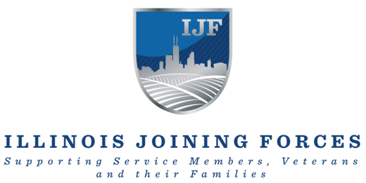
Illinois Joining Forces Awarded Grant funding from Dunham Foundation to Support Area Veterans

AURORA, ILLINOIS – Illinois Joining Forces (IJF) announced today that it has been selected for one year of grant funding from the Dunham Foundation to advance the lives of Illinois’ veterans in the following areas:
- The Aurora Region Veteran Support Community (VSC) – A growing collaboration of community stakeholders and veteran-focused organizations working together to support area Veterans. IJF believes that services are best delivered closest to home. By working together with community partners and resource providers, veterans can access the services they need and deserve.
- IJF’s Care Coordination Center (CCC) — IJF’s Care Coordination Specialists are veterans themselves and they provide high-touch, holistic resource navigation to IL Veteran and their families. Seldom does a veteran have a single need. The IJF Care Coordination Specialists act as a guide with a warm handoff to the myriad of resources available.
- Veteran Peer Support Training for 8 Aurora region veterans to serve their brothers and sisters in arms. Based on the principle of shared experience, peer support has proven to be an extremely effective way of assisting fellow veterans transition back into civilian life and address the many challenges they face along the way. IJF is partnering with the Roosevelt-Aurora American Legion Post #84 and the Kane County Veterans Assistance Commission and other area stakeholders to recruit veterans to be professionally trained as Peer Support Specialists
The mission of IJF is to bring together public, private, and government stakeholders in collaboration to support currently serving service members (including Guard and Reserve), veterans, and their family members regardless of status.
“We are grateful to the Dunham Foundation for their partnership and support.”, said IJF Executive Director, Steve Curda, Brig. Gen. (retired). Curda continued, “The Dunham Foundation has a long tradition of supporting vital community efforts in Aurora and surrounding communities. IJF is honored to be welcomed into the family and we look forward to upholding that tradition as we serve the Aurora veteran community.”

###
About Illinois Joining Forces
Illinois Joining Forces (IJF) was launched in 2012, through an inter-governmental agreement between the Illinois Departments of Veterans’ Affairs (IDVA) and Military Affairs (IDMA) as a statewide, public-private network of military and veteran serving organizations working together to improve services for Service Members, Veterans and their Families (SMVF).’

About The Dunham Foundation
The Dunham Foundation (Foundation) began providing grants in 2007 and strives to honor John C. Dunham’s vision for building and supporting a healthy, thriving community. The Foundation seeks grant applications from nonprofits whose work aligns with the Foundation’s mission, and encourage innovation and collaboration in educational and community development programs and projects to effect positive change in the Dunham Foundation service area.

