Veteran
Support
Communities

TARGETED: Identified and scanning resources/assets

DEVELOPING: Working with community partners and validating sustainability

ACTIVE: Regular meetings with partners and sharing resources, making referrals

Development
Phases
Veteran support communities bring together local Veteran resource providers and other community assets. The initiative will help more efficiently and effectively meet the needs of Servicemembers, Veterans and their Families (SMVF) throughout the state of Illinois
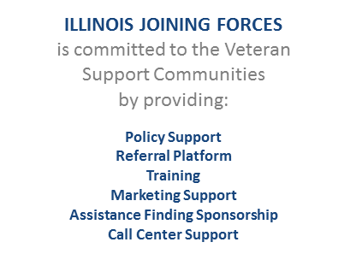

Housing
Employment
Financial Assistance
Medical
Education
Women Veterans
SUCCESS ATTRIBUTES​
Central Hub Organization​
Convening Authority​
Core Partners​
Referral Platform​
Peer Support Capacity​
Corporate/Private Sponsorship​

CALL 833-INFO-IJF FOR ASSISTANCE,
OR VISIT ILLINOISJOININGFORCES.ORG

VSC Status
Lake and McHenry Active
NVI Funded
Rockford Targeted
Chicago (MVI)
Roger Park Active
Austin Active
Mid-south (Bronzeville) Active
Aurora Developing
Quad Cities Active
NVI Funded
Joliet Active
Southland Developing
Kankakee Developing
Peoria Active
Bloomington/Normal Developing
Champaign/Urbana Developing
Quincy Active
NVI Funded
Capitol Area Active
Effingham Developing
Metro East Developing
Mt Vernon Targeted
Southern IL Active
19 veteran support communities
Current status of Veteran Support Communities

Lake/McHenry
Rockford
Aurora
Joliet
Kankakee
Peoria
Bloomington
Quincy
Champaign
Quad Cities
Capitol Area
Effingham
Metro East
Mt. Vernon
Chicago
S. Illinois
Southland

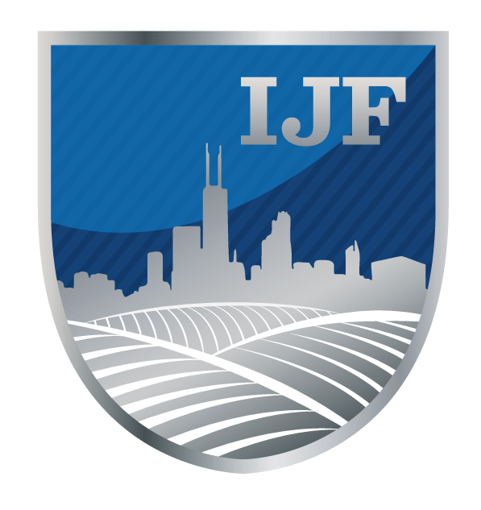
TARGETED: Identified and scanning resources/assets

DEVELOPING: Working with community partners and validating sustainability

ACTIVE: Regular meetings with partners, sharing resources, making referrals
Development Phases

